

**ACER User Guide**

Oleh Karpa

Centre for Ships and Ocean Structures (CeSOS)

Norwegian University of Science and Technology (NTNU)

Trondheim, Norway

October, 2012 (Revised January 2022)

Table of Contents

1. Definitions 3

2. Installation 3

3. Step by step usage 4

3.1. Building of the ACER functions. 4

3.2. Choosing the desired ACER function and its tail marker. 8

3.3. Optimization final plotting and extrapolations. 10

References 14

# Definitions

The “ACER_v2” program is an executable Graphical user interface (GUI) file for implementing the ACER method. It includes routines for calculation and plotting of the ACER functions; estimation of the parameters for the optimal fitted curve; estimation of a confidence interval for the predicted extreme value provided by the optimal curve.

# Installation

1. The ACER_v2 release executable file for Windows on 32-bits platforms can be downloaded from the FTP folder <https://folk.ntnu.no/arvidn/ACER_32/>
2. If you have MATLAB version 7.9.0 (R2009b), 32-bit (win32) installed on your machine, follow the link below to download ACER GUI application and proceed to the Chapter 3:

<https://folk.ntnu.no/arvidn/ACER_32/ACER_v2.exe>

1. ACER graphical user interface application with MATLAB Compiler Runtime file can be downloaded from <https://folk.ntnu.no/arvidn/ACER_32/ACER_v2_pkg.exe>. MATLAB Compiler Runtime file MCRInstaller.exe is necessary to install all required components on the machine without installed Matlab and to be able to start the ACER program.
2. Save ACER_pkg.exe and execute it. You’ll see a window, as shown in Figure 1. This is a self-extracting (SFX) WinRAR archive, which contains two files: ACER_v2.exe – the main program and MCRInstaller.exe – MATLAB Compiler Runtime file.

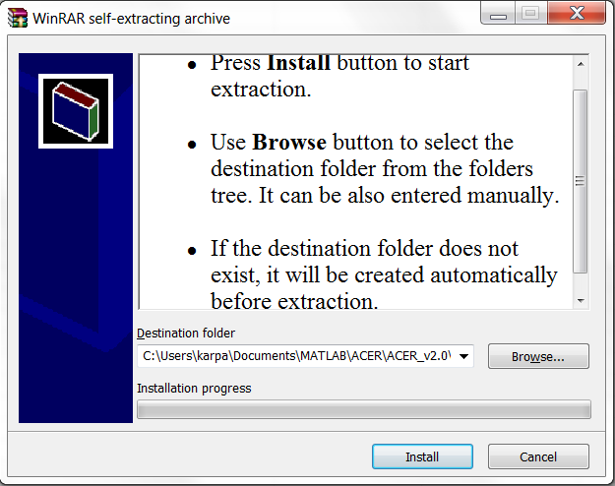  
Figure 1: Extraction of files

1. Using “Browse…” and “Install” buttons to extract files. Installation of MATLAB Compiler Runtime (MCR) will start automatically after extracting files. This is crucial since the MATLAB Compiler lets you run ACER_v2 application outside the MATLAB environment.

We recommend that you to restart your computer after setup has finished.

# Step by step usage

## Building of the ACER functions.

1. Make sure that the time series data you want to analyze are saved properly: in columns (or rows), where one column (one row) contains data of one realization. Data should be saved in files of the following formats:*.txt, *.dat, *.mat or even *.xls. See Figure 2, as an example:

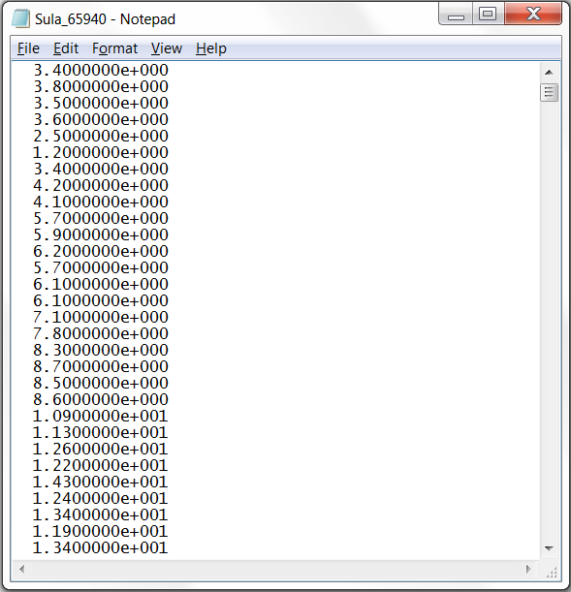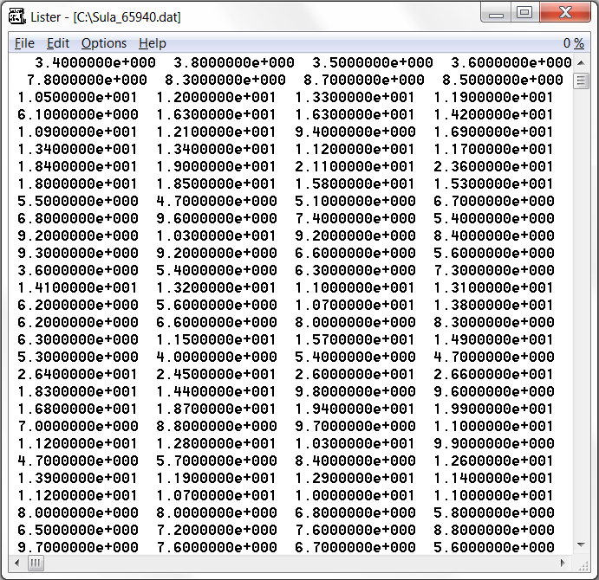

Figure 2: Saved data in files: left – one column *.txt file; right – several rows *.dat file.

1. Run ACER_v2.exe program (see Figure 3)

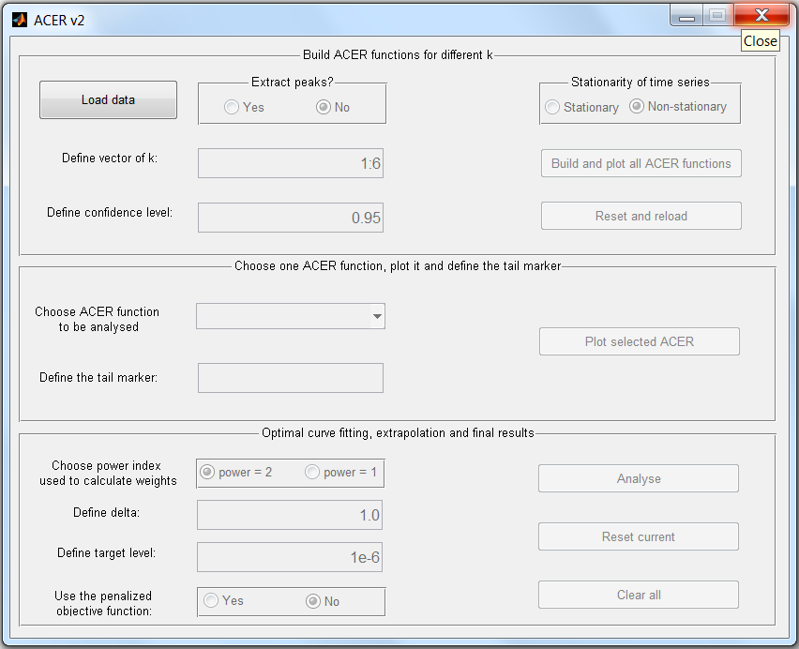

Figure 3: ACER program main window.

Within the first section “Build ACER functions for different k” you have to load data and initiate constants that enable calculation and plotting of ACER functions.

1. Load your data by pressing corresponding button . After data is loaded to the system, all text fields and buttons within the first block become active.
2. The next block of the program contains radio buttons that allows the extraction of peak values of the time series . Extraction of peaks depends on the kind of data you have. If you are sure the data you have sampled come from a narrow-banded process, you may use only peak data for the analysis of the conditional exceedance rates. Thus choose “Yes”. If your data are governed by more broad-banded process or if the data could be considered as the peaks data already (e.g. hourly or 3 min maxima, etc.), extracting peaks may be less relevant, so press “No”. (“No” is set as a default choice).
3. The vector of k’s is defined within next text box: . Elements  of this vector are the sub indexes of the ACER function, where *k*–1 is the number of conditionings on previous non-exceedances, i.e. there should be at least one value of vector *k*. Elements of k should be written in one of the MATLAB vector writing formats: separated by colon  , which denotes *n* values in consecutive order; separated by comma ; combined. For instance, the default values are 1:6.
4. Further, a confidence level expressed as a fraction of unity should be defined, i.e. for 95% confidence level use 0.95. Default level is 95%: .
5. Stationarity of the loaded time series should be defined within the last block of the first section. Empirical estimation of the ACER functions depends on the chosen value. According to Naess and Gaidai (2009) the modified ACER function applies to nonstationary processes. “Nonstationary” is set as a default value.
6. Now you are able to calculate and plot ACER functions by pressing “Build and plot all ACER functions” button: .

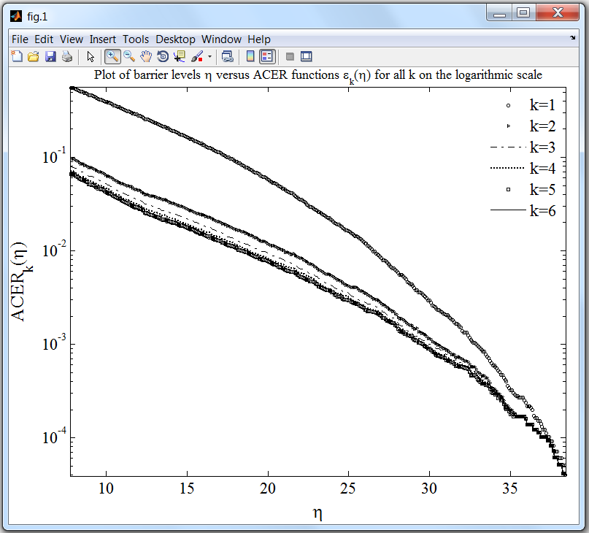

Figure 4: Plots of ACER functions

1. Together with plots of ACER functions (Figure 4) you will get a message window with the calculated number of points (or peaks if extracted) of the loaded time series. You’ll need this number when the target level will be defined

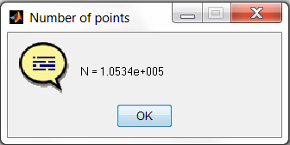

A message window with the number of realizations of the loaded time series will appear in addition to information about number of points. Thus, if you have provided time series with *R* realizations you will get a message (here *R* = 12):

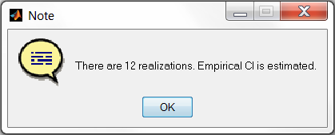

This means that the 95% confidence interval *CI* = (*CI*–(*η*), *CI*+(*η*)) for the ACER function  is estimated using formula , where *τ = t* –1 ((1– 0.95)/2, *R* – 1) – corresponding quantile of the Student's *t-*distribution with *R –* 1 degrees of freedom and  *–* sample standard deviation estimated by the basic formula.

In case only one realization is available, the way to estimate a confidence interval is to assume that the number of conditional up-crossings follows Poisson distribution *Poiss*(), which asymptotically is Gaussian *N*(, ). Then , with corresponding quantile *ν* of the Gaussian distribution.

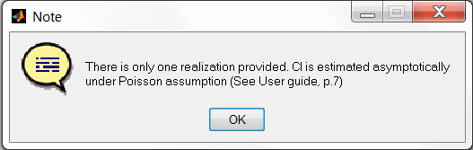

1. If you have decided to reload data, or there was an error in the loaded file\ defined vector of k or confidence level, use “Reset and reload” button: .

## Choosing the desired ACER function and its tail marker.

The second section allows you to choose one of the available ACER functions, plot it and define the tail marker.

1. Choose one of the built ACER functions in the corresponding pop-up window:

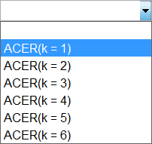

1. Active button on its right plots chosen function (see Figure 5)

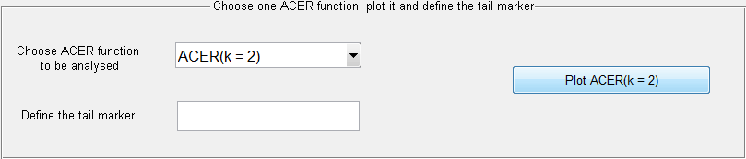

1. Further, the tail marker should be defined within the text window below. The value of the tail marker corresponds to the value of the threshold *η1*, from where the chosen ACER function starts to behave regularly. To be able to find an appropriate value, use the “Data Cursor” button  on the figure window tools panel or by simple visual inspection of the plot:

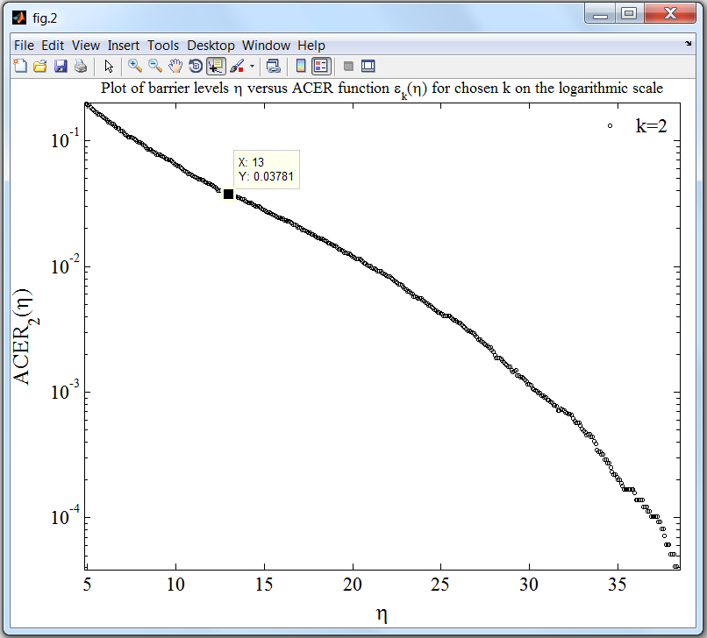

Figure 5: Plot of chosen ACER function.

Find the tail marker and assign this value: 

## Optimization final plotting and extrapolations.

Now you may proceed to the last section (or, of course, start from the very beginning by pressing “Reset and reload” button in the first section: )

1. The power of the weights of the objective function should be determined within the radio buttons group . Usually the values 1 and 2 are used. The value 2 is the default one.
2. To cut from consideration the very tail of the data, where uncertainty is considered too high, you should choose the value of the constant delta within the corresponding text window: . It is a real positive number in the closed interval [0.5, 1]. This parameter is equal to 1 in the program by default. This ensures that no complex numbers will occur while taking log of. This also leaves enough data points for the weighted optimization problem.
3. The target level you want the ACER function to be extrapolated to should be defined in the last text box: . The target level is the ratio of the time interval between two data points (or between two peaks if peaks was extracted and analyzed) and the desired time horizon, which is the return period for the predicted value. The easiest way to calculate the target level is to use the text formula:

, where N is the number of data points (or peaks). The time horizon and duration of observations should be expressed in the same units.

1. Finally, the type of the objective function used to find optimal parameters has to be defined within the last group of two radio-buttons: . There are two possible choices: use penalized objective function and use basic objective function. In case “No” the objective function is a mean square error function, as defined by Naess and Gaidai (2008). When “Yes” button is depressed the ACER program uses a penalized objective function, which is the basic mean square error function multiplied by a penalty function of the parameter *c*. The penalty function ensures that the resulting distribution is attracted toward the correct asymptotic form.
2. Now you can run the main part of the program by clicking “Analyse” button .
3. The optimization process takes some time, so you should wait until the final plot appears (see Figure 6):

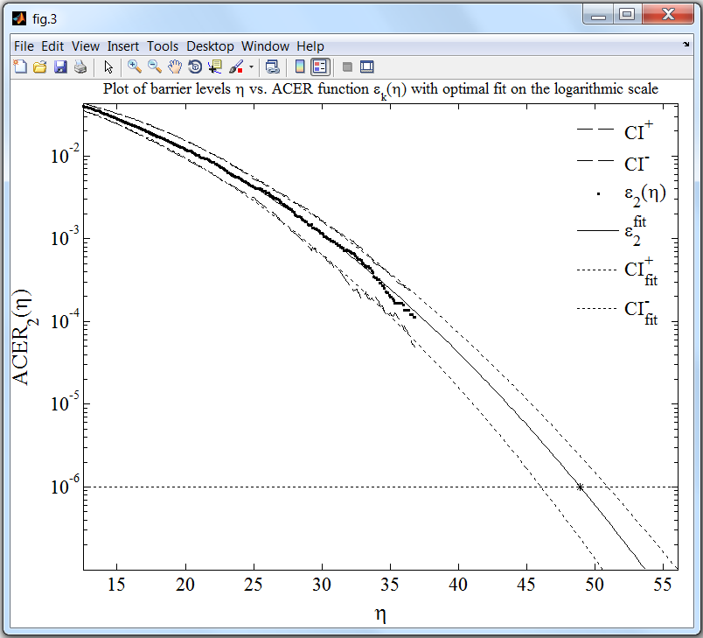

Figure 6: Final plot of extrapolated optimal curve and confidence bands.

1. The ACER program saves the final results in *.txt file (see Figure 7). The file name contains the name of the loaded data file, the chosen and analyzed ACER function with sub index *k* and is saved to the same folder where the loaded data file is located.

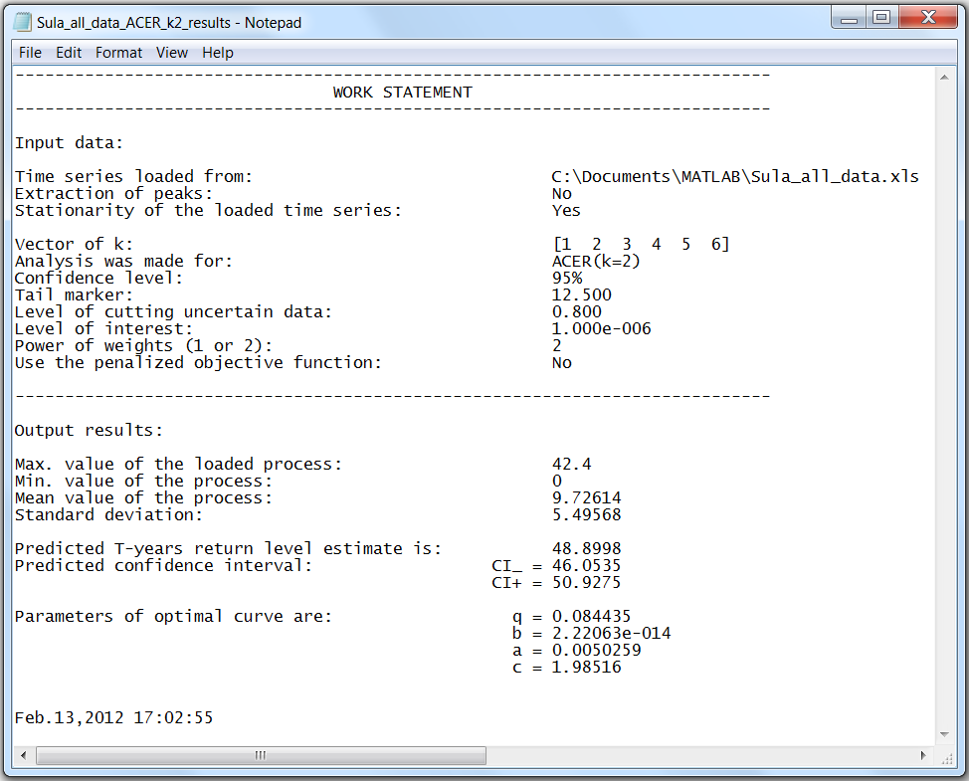

Figure 7: Saved results

1. Output results are: Min. and Max. values of the loaded process, its mean value and standard deviation, predicted return level, predicted confidence interval and parameters [q, b, a, c] of the optimal curve of the form q·exp{–a·(η – b)c}.
2. By pressing the “Reset current” button:  you may start to analyze another ACER function (for another *k*).
3. By pressing “Clear all” button  you’ll get to the very beginning of the program.

References

Naess A, Gaidai O, Batsevych O. Prediction of Extreme Response Statistics of Narrow-Band Random Vibrations. J. Eng. Mech. ASCE 2010; 136(3).

Naess A, Gaidai O. Estimation of extreme values from sampled time series. Struct Saf 2009; 31: 325-334

Naess A, Gaidai O. Monte Carlo Methods for Estimating the Extreme Response of Dynamical Systems. J. Eng. Mech. ASCE 2008; 134(8).

Naess A, Gaidai O, Karpa O. Estimation of Extreme Values by the Average Conditional Exceedance Rate Method. Journal of Probability and Statistics Volume 2013, Article ID 797014, http://dx.doi.org/10.1155/2013/797014.